Automatic Headlamp System

Intelligent headlamp systems via uv measurement

Johnson, Matthew H.

2019

# Abstract

For my independent design study project, I plan to build an automatic headlamp control for a 12-volt automotive headlamp system. This project will work to implement an automotive system where when the vehicle is on, illumination of the headlamps will be controlled automatically via a daylight sensor. If daylight is not detected, the headlamps will turn on after a user set delay. This will prevent headlamps from coming on prematurely when driving through shade for a moment. Once headlamps are on, if daylight is detected, another timer will begin for a user set time before the headlamps are shut off.

Detection of light will be handled via an ultraviolet (UV) sensor of choosing. The output voltage from the UV sensor will be input to a comparator, and if below a user chosen threshold, will activate an initial delay circuit. If the given-on delay has completed, a secondary timer circuit, relay, and headlamps will activate.

If the headlamps are on and voltage from the UV sensor to the comparator goes above the user chosen threshold (senses daylight), power to the initial and secondary timer circuits and the relay will be removed. When power is removed from the secondary timer circuit, a pulse will be sent out via a discharging capacitor to the trigger of the secondary timer circuit. This will begin a timer countdown that will keep the relay activated, being as a 555 switches faster than an automobile relay does. With the relay remaining active while the timer is counting down, the headlamps remain on and active.

If during the countdown to turn the headlamps off sensed light is removed, power will be restored to the circuit and the turn off sequence will be aborted.

# Design

For this project a General Motors (GM) factory daylight sensor was used to detect ambient light. Using an original equipment manufacturers website, a GM part number for a 2000 Chevrolet Silverado’s automatic headlamp control system was found to be 12450120. The part was ordered, but no data sheets were able to be obtained to be used with this sensor. Using a Fluke meter, the sensor was probed and was determined to have diode characteristics with a 1.60 V forward diode drop. The sensor was then plugged into a breadboard along with a LED, a 9V battery, and various resistors to attempt controlled output. Bringing the sensor into direct sunlight it was found that the sensor output ~3 volts in sunlight and dropped below 1 volt going to 0 in dark conditions when connected to a VCC of 9 volts.



An LM293 op-amp was initially specified to control the circuit by comparing the GM sensor output to a set voltage level. The LM293 was replaced with a LM324 when during testing it was found that at the turn on relay in the circuit voltage was being pulled down well below 14 volts, preventing the relay from turning on, thereby necessitating a voltage regulator to overcome this problem. The voltage threshold for the comparator was initially set to 2.12 V, but during in-car testing it was found to work better at thresholds closer to 1 V (1.07 V set value). The comparator was setup to output 14 volts when light was not sensed, and 0 volts when light was detected.

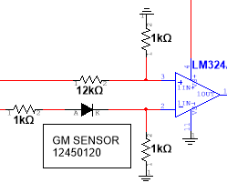

The output from the LM324 comparator is then sent to the reset of a 555 timer, setup in bistable mode, and to the base of a 2N3906 PNP transistor. This 555 timer needs to be able to be delayed turning on to account for momentary shade conditions that do not necessitate using headlights. By applying 14 volts to the reset the 555 timer has now been enabled. The emitter of the PNP is connected to the control pin of the 555 timer, with the control pin having a constant output of 2/3 VCC. When the comparator output is low (ambient light detected) there is no current on the base of the PNP, therefore voltage flows through to the collector and keeps the 47 uF capacitor connected to the trigger of the 555 charged to 2/3 VCC. When the comparator output is high, current is applied to the base of the PNP thereby removing the voltage flowing through to the collector. This causes the capacitor connected to the trigger to begin discharging (yellow line in diagram), allowing a 1.94 second delay (BX-AX) before voltage is low enough at the trigger to cause a output of the 555 circuit (pink line in diagram). If light should be detected before the trigger event has happened, then the capacitor will cease draining and begin charging back up (yellow line).



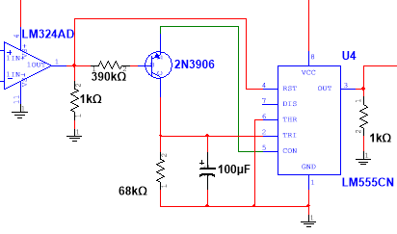

The output from the bistable 555 timer was then sent to a LM324 that was being used in conjunction with a 2N2222A NPN transistor to build a voltage regulator as taught by Dr. Fitzmorris. The loads are connected to the emitter of the 2N2222A. This part of the circuit was added when during testing it was found that output from the bistable dropped considerably below 14 volts due to loads placed on it, thereby preventing a relay used in the next part of the circuit from working. This allowed the output to the next part of the circuit to either be a regulated 14 volts, or 0 volts.

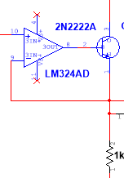

In the last part of the circuit another 555 timer is used, this time setup in monostable mode, to keep the headlights on for a delayed period when light is sensed before turning off. This circuit works by when the sensor sees no light, the LM324 outputs 14 volts. This 14 volts travels through a 1N4001G rectifier diode to energize the coil of a 12 volt relay, which turns on sending 14 volts from the relay to the headlamps and the 555 circuit. The LM324 output also connects to the cathode of a 1 μF capacitor that has its anode connected to the trigger of the 555 timer. With the relay on and no light being sensed this puts 14 volts at the headlights, the 555 VCC, the 555 reset, the 555 trigger, and both sides of the 1 μF capacitor. When light is removed the LM324 outputs 0 volts (pink line) to the cathode of the trigger connected capacitor and to the 1N4001G diode connected to the relay. A relay is a mechanical device, so when voltage is removed from the 1N4001G diode it takes time for the relay to mechanically switch off. When the cathode of the 1 μF capacitor switches to 0 volts, the anode side (connected to 555 trigger) drops immediately to 0 volts (yellow line) before charging back up, causing the 555 monostable to trigger. At this point the 555 outputs 14 volts (light blue line) through a 1N4001G diode to the relay which has yet to switch off, as it is slower switching, allowing the circuit to self-sustain for a period of 9.4 seconds (t=1.1 * 82kΩ * 100 μF).

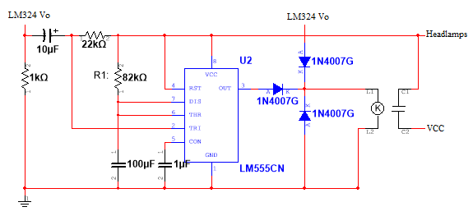

The final part of this project was the actual installation and usage in a real-world vehicle. A 2000 Honda Accord was used as a test bed for this project. By studying a wiring diagram for the car it was found that to activate the headlights and combination lights there were two wires that needed to be found and put to ground. For the headlights a black/red wire and for the combination lights a red/yellow wire. Once these wires were found they were added to the headlight control system using relays that when activated would simply put the wires to ground. Initially two relays were used, one for the headlights, one for the combination lights, but during reliability calculations this decision was reevaluated and an alternative single relay was found that could have two accessories (pin 87 relay) connected. So for wiring pins 85 and 30 go to ground, 86 goes to the auto headlamp circuit, and 87/87b go to the BL/R and R/Y wires on the Honda Accord. This change brought reliability from 50.5% to 59.63%.

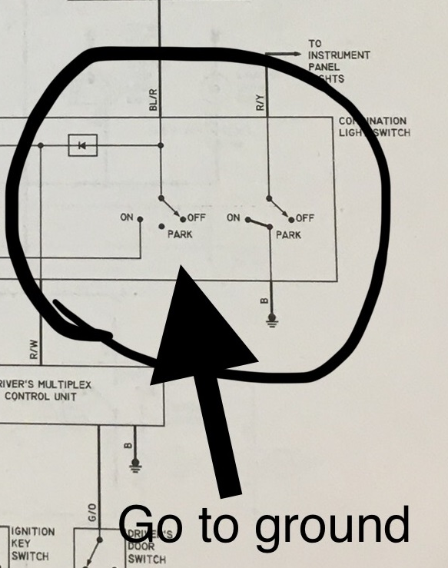

# Circuit Reliability Theory

Part failure rate is defined as $λ_{p}=λ_{G}π_{Q}\frac{failures}{{10}^{6}}hours$, where λG is the generic failure rate and πQ is the quality factor. There are three environments for generic failure rate: GB (ground benign), GF (ground fixed), and GM (ground mobile). As this circuit was used in an automotive application, GM values for generic failure rate were used to calculate circuit reliability for one year. Reliability is calculated for one year as $R=e^{-total*{10}^{-6}}*365.25*24$

|  |  |  |  |  |  |
| --- | --- | --- | --- | --- | --- |
| Qty | Part | λGM | πQ | λP | Qty*λP |
| 12 | Carbon film resistor | 0.013 | 10 | 0.13 | 1.56 |
| 4 | Capacitors, Electrolytic | 0.42 | 10 | 4.2 | 16.8 |
| 1 | LM324 IC | 0.039 | 10 | 0.39 | 0.39 |
| 2 | Si npn/pnp transistors | 0.0017 | 8 | 0.0136 | 0.0272 |
| 2 | LM555 IC | 0.039 | 10 | 0.39 | 0.78 |
| 4 | Gen Purp Diodes | 0.049 | 8 | 0.392 | 1.568 |
| 1 | LED | 0.0056 | 8 | 0.0448 | 0.0448 |
| 2 | Relay | 2.1 | 9 | 18.9 | 37.8 |
|  |  |  |  | Total: | 58.97 |
|  |  |  |  |  |  |
|  | Reliability: | 59.63% |  |  |  |

# Circuit Design Sourcing & Future Designs

The design of this circuit was drawn from several resources. For the design of the delayed off circuit a delayed off headlight control system was found in a book entitled “110 Integrated Circuit Projects for the Home Constructor” by R. M. Marston from 1978 (pages 40-41). This circuit used an ignition switch activated system and had to be modified to be activated by the GM sensor and to prevent the voltage pulldown at the 1N4007G diode at the relay. For the delay on circuit a bistable design without using a PNP was initially used, but when integrated with the delayed off circuit was found to be inconsistent in its desired results. This led to changing to a design found at <https://www.electronics-project-design.com/timedelaycircuit.html>, which utilized a PNP transistor to control the trigger of a 555 timer in bistable mode.

After having had this circuit installed in a 2000 Honda Accord for several weeks now, some observations and thoughts on modification of this circuit are presented. At dusk or dawn, when the sensor is at the threshold for turning the system on or off, sometimes an issue occurs where the system bounces on and off as sensor voltage fluctuates from 1.06 V to 1.08 V during this transition period (comparator set to 1.07 V). My thought on how to fix this is to build a buffer into the comparator, where turn on voltage is set at 1.07 V, but once on this value changes to 1.17 V until off when the value goes back to 1.07 V for turn on. This could possibly be accomplished using feedback and a diode in some fashion to the comparator.

Update: Having added a 1N914 diode and a 100k resistor as feedback to the positive input on the comparator has the intended effect. When no light is detected and the comparator is on, the compare value now changes to ~1.18 V. Once light is detected the compare value returns to 1.07 V. Further testing will be conducted to see if this fixes the bounce issue at dusk and dawn.

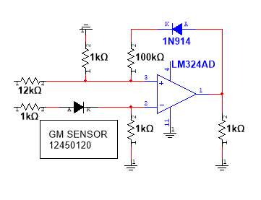

# Appendix

